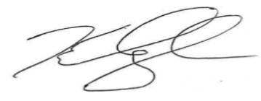

**E**

**N**

was initiated as a member of the

chapter of Chi Alpha Sigma in recognition of high academic and athletic achievements on

Executive Director Chapter Advisor